
Contents
1
1 Database Requirement 2
1.1 Scenario 2
1.2 Data Requirements 2
1.3 User and System Requirements 2
2 Database Design 3
2.1 Conceptual Design 3
2.2 Schema and Mapping 3
2.2.1 Basic step 3
2.2.2 Multi-valued attributes 4
2.2.3 Composite attributes 4
2.2.4 Relations 1:M and 1:1 4
2.2.5 Relations M:M 5
2.2.6 Final schema! 5
2.3 Normalization 6
2.3.1 1st NF 6
2.3.2 2nd NF 8
2.3.3 3rd NF 10
2.4 Logical Design 12
2.5 Physical Design 13
2.6 Effectiveness of the Design 14
References 19

Database Requirement

Scenario
The school has multiple clubs that many students can enroll in since each club has its ID, office on campus, and phone number. Candidates from different grades and clubs can enroll in clubs using their ID, name, and phone number. The school has decided to hold an election for each club, and based on the number of votes each candidate gets the school system will determine the winner. Clubs have voters who can only vote for one candidate using their ID, and name. Each club has many teachers with different roles in each club to mentor the candidates. Teachers have their IDs and addresses.

Data Requirements
- Each club is uniquely identified by their name, ID, office(address), and phone number.
- Clubs have candidates. Candidates enroll using their ID, name, and phone number.
- Voters vote for only one candidate using their ID, and name.
- Teachers mentor the candidates; teachers have different names, roles, and IDs.

User and System Requirements

User requirements and functional requirements:
Teachers’ requirements:
T1: a user will be generated for them; they will be granted privileges on the candidates, voters, and votes table.
T2: Generate a report showing the number of candidates, and who voted for them.
T3: teacher can view the candidates that they will mentor and in which club are they enrolling
Candidates’ requirements:
C1: the system will take their name, ID, and the phone numbers
C2: they should be able to view, and update their information
C3: check the votes they are receiving from the voters
Voters’ requirements:
V1: they can vote for a candidate within the club
V2: Voters can view
V3: Update their information
Clubs’ requirements:
R1: store the students (candidates and voters) who are enrolled in the club
R2: take their names and IDs and store them
R3: be able to view the information of anyone who is a member of the club
System requirements:
- S1: system must be secure
- S2: the system must be updated
- S3: it must be maintainable, backed up, and consistent.
- S4: the system must keep the data confidential
- S5: the data must be integral and available

Database Design

Conceptual Design
A conceptual design determines what entities are included what should exist and what shouldn’t. it also shows the relationship between them. The conceptual design is just a blueprint for the final design that the developers must come up with based on the user requirements.

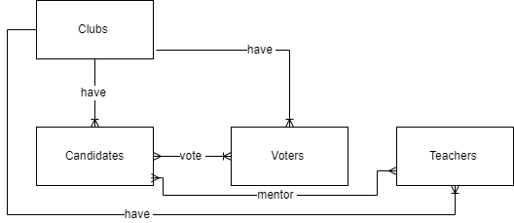

The club has candidates, voters, and teachers as mentors. Many teachers mentor many candidates in the club. As for the voters, they can vote for many candidates, so they have a M: M relation.

Schema and Mapping

Basic step
Club (ID, address, name, phone number)
Candidate (ID, phone number, name)
Voters (ID, name)
Teachers (ID, role, name)
No derived attributes, so we don’t change a thing

Multi-valued attributes
- Club (ID, address, name, phone number)
- Candidate (ID, phone number, name)
- Voters (ID, name)
- Teachers (ID, role, name)
They must be extracted to a new table
- Club (ID, name)
- Club_address(ID, address)
- Club_phone(ID, phone number)
- Candidates (ID, name)
- Candidates_phone(ID, phone number)
- Voters (ID, name)
- Teachers (ID, role, name)

Composite attributes
- Club (ID, name)
- Club_address(ID, address)
- Club_phone(ID, phone number)
- Candidates (ID, fname, lname, email)
- Candidates_phone(ID, phone number)
- Voters (ID, fname,lname, email)
- Teachers (ID, role, fname,lname)

Relations 1:M and 1:1
Remember the Rule: In 1:1 relation and 1:M relation, we should link tables by adding references from the PK to FK.
Clubs: candidates 1:M (have)
Clubs: teachers 1:M (have)
Candidates: voters 1:M (vote)
Clubs: voters 1:M (have)
- Club (ID, name)
- Club_address(ID, address)
- Club_phone(ID, phone number)
- Candidates (ID, fname, lname, email,club_id)
- Candidates_phone(ID, phone number)
- Voters (ID, fname,lname, email, candidates_id,clubs_id)
- Teachers (ID, role, fname,lname, club_id)

Relations M:M
Any many-to-many (M: N) relation will be represented as a new table. The primary key of this table will be a combination of the primary keys of the two ends of the relation
Candidates: teachers M:M (mentor)
- Club (ID, name)
- Club_address(ID, address)
- Club_phone(ID, phone number)
- Candidates (ID, fname, lname,club_id)
- Candidates_phone(ID, phone number)
- Voters (ID, fname,lname,clubs_id)
- Teachers (ID, role, fname,lname, club_id)
- Votes (Voter_id, candidate_id)
- Mentor (teacher_id, candidate_id)

Final schema!
- Club (ID, name)
- Club_address(ID, address)
- Club_phone(ID, phone number)
- Candidates (ID, fname, lname,club_id)
- Candidates_phone(ID, phone number)
- Voters (ID, fname,lname,clubs_id)
- Teachers (ID, role, fname,lname, club_id)
- Votes (Voter_id, candidate_id)
- Mentor (teacher_id, candidate_id)

Primary keys are underlined, and the foreign is underlined and highlighted.
Weak entities are colored in blue.

Normalization
There are three normal forms, the first normal form says that each cell should have only atomic values, no composite or multi-value attributes. Each record must be unique, values must be stored in a column with a unique name, and everything stored in the column must be from the same domain. The second normal form says that the first normal form must be applied and no partial dependencies must be applied; all the non-key attributes are fully functional dependent on the primary key. Finally, the third normal form says that the first two normal forms must be applied in addition to removing all transitive dependencies found. All the attributes must be identified only by the candidate keys of the relation and not any non-prime attributes; break the relation to two relations.

1st NF

Relations | Attributes | Violation Description | Solution – Relations
The relations schema | The attribute name | Describe why it is not in the 1st NF (the violation) | Show the schema for each affected relation.
Club (id, address, phone number, name) | Phone number and address | Phone number and the address are multi-value attributes | Club (ID, name)  Club_address(ID, address)  Club_phone(ID, phone number)
Candidates (ID, name, phone number) | Phone number and name | Phone number is a multi-value, and the name is a composite attribute | Candidates (ID, fname, lname,club_id)  Candidates_phone(ID, phone number)

Example
Before:

ID | Address | Name | Phone number
12345 | Amman | Rania | 0792300908
23456 | Amman | Mohammad | 0793300706
12435 | Irbid | Ahmad | 0793450697

After:
ID | Address | Name
12345 | Amman | Rania
23456 | Amman | Mohammad
12435 | Irbid | Ahmad

ID | Phone number
12345 | 0792300908
23456 | 0793300706
12435 | 0793450697

2nd NF

Relations | FDs | Violation Description | Solution – Relations
The relations schema | Show the functional dependencies causing the violation | Describe why it is not in the 2nd NF (the violation) | Show the schema for each affected relation.
Candidates (CID, fname, lname, phone number, voters_id, fname, lname) | CID [fname, lname,phone number]  VotersID [fname, lname] | Fname and lname of the candidates depend on the primary key (CID) and the non-prime attributes fname and lname of the voters depend on the voters id which is a primary key. So, we have a partial dependency | Candidates (ID, fname, lname,club_id)  Candidates_phone(ID, phone number)  Voters (ID, fname,lname,clubs_id)  Votes (Voter_id, candidate_id)
Clubs (id, address, name, voters_id, fname, lname) | Club_id [address, name]  Voters_id [fname, lname] | Two one-to-many relationships were combined into one single table with a new primary key (id). We have a partial dependency, the non-prime attributes (address, name) depend on part of the primary key (id) and the other non-primary keys (fname, lname, emai) depend on the other part of the key (voters_id) | Voters (ID, fname,lname,clubs_id)  Clubs (id, address, name)

Before
Candidates ID | Fname | Lname | Phone number | Voters_id | Fname | Lname
1234 | Ahmad | Mustafa | 0792802820 | 22342 | Rami | Musa
1345 | Ramia | Jalal | 0792380980 | 12342 | Jalal | Mustafa
1234 | Ahmad | Mustafa | 07923065856 | 22342 | Sima | Jadi

After
Candidates ID | Fname | Lname
1234 | Ahmad | Mustafa
1345 | Rami | Jalal

Candidates ID | Phone number
1234 | 0792802820
1234 | 0792380980
1345 | 07923065856

Voters_id | Fname | Lname
22342 | Rami | Musa
22342 | Sima | Jadi
12342 | Jalal | Mustafa

Voters_id | Candidates ID
22342 | 1234
12342 | 1345
22342 | 1234

3rd NF

Relations | FDs | Violation Description | Solution – Relations
The relations schema | Show the functional dependencies causing the violation | Describe why it is not in the 3rd NF (the violation) | Show the schema for each affected relation.
Candidates (id, fname, lname, phone number, club_id, name, address, phone number, voters_id, voters_fname, voters_lname) | Candidates_id club_id  Club_id [ name, address, phone number]  Candidates_id [name, phone, address] | The PK (ID) can determine any attribute in the table including clubs_id. The clubs_id determines the name, address and phone number. As the club_id is not a candidate here, we have a transitive dependency | Candidates (id, fname, lname, phone number)  Club (ID, name)
Candidates (CID, fname, lname, phone number, voters_id, fname, lname) | CID teachers_id  Teachers_id [role, fname, lname]  CID [role, fname, lname] | The PK (ID) can determine any attribute in the table including candidates_id. The candiates_id determines the role, fname and lname of the teachers.As the teachers_id is not a candidate here, we have a transitive dependency. | Candidates (ID, fname, lname,club_id)  Teachers (ID, role, fname,lname, club_id)  Mentor (teacher_id, candidate_id)

Before:
Club_id | Name | Address | Phone number | Candidate  ID | Fname | Lname | Phone number
6446 | Art | Office 5 | 0798585689 | 1234 | Ahmad | Mustafa | 0792802820
6136 | Reading | Office 6 | 0792300509 | 1345 | Ramia | Jalal | 0792380980

After:
Club_id | Name | Address | Phone number
6446 | Art | Office 5 | 0798585689
6136 | Reading | Office 6 | 0792300509
Candidates ID | Fname | Lname | Phone number
1234 | Ahmad | Mustafa | 0792802820
1345 | Ramia | Jalal | 0792380980

Logical Design

Logical design is the actual implementation of the database. The conceptual design is transformed from the high-level data model into the implementation data model. In the logical design, the attributes and keys are included by adding the features included in the conceptual design (entity names and relationships). This figure shows the strong and weak entities and their relationship, as it also shows the attributes of the entities.

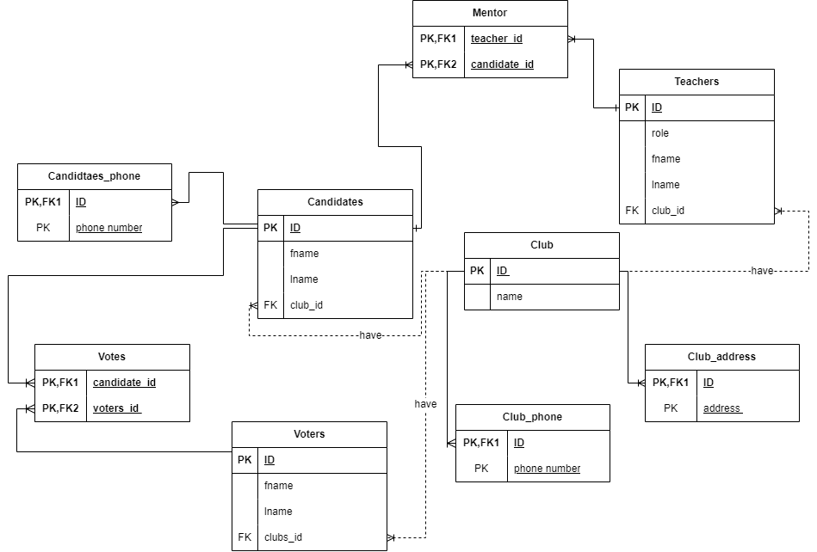

Physical Design
It is derived from the logical model, and then we define data types for the fields and define constraints on the tables. Depending on the attributes the data type fields are distributed accordingly.

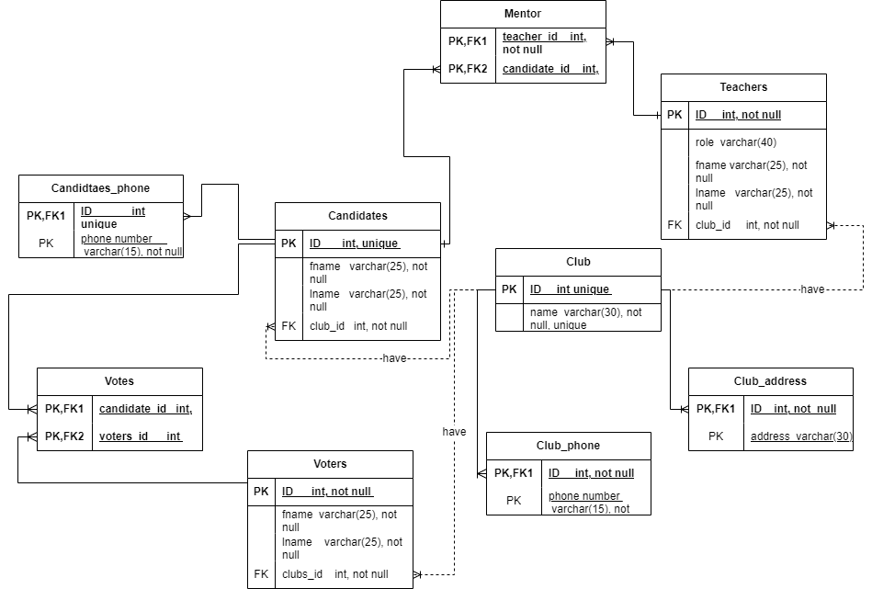

Effectiveness of the Design

At first, my scenario includes a school being described as a whole and no attributes describing it were mentioned; however, my system talks about the clubs, the election, and the elements included in the election. The election consists of candidates, teachers to mentor the students, and the voters who vote for the candidates. Each club has a unique ID, name, phone number, and address (office). Each candidate and voter must have an ID, name, and phone number to identify and differentiate between them. Candidates, voters, and teachers are unique to each club this is why they are a 1:M relation. Voters can vote for many candidates, and teachers mentor many candidates, so they have a M: M relationship.

The conceptual design is a high-level blueprint that transforms the idea into a visual design based on how the database should be structured. The target audience of conceptual design is people who will view, use, or benefit from the design. Non-technical users must be able to read the conceptual design and understand it. My conceptual design includes the entities (club, candidates, voters, teachers) that are represented in rectangles and the relationships between them. Relationships can be categorized based on their cardinality; my conceptual design contains a one-to-many relationship between the clubs and the voters, candidates, and teachers since the clubs are one set and it is related to multiple entities in another set. Each club has many teachers, candidates, and voters in this case. The conceptual design also includes many-to-many relationships between the candidates and voters, and teachers and candidates. Since many voters can vote for many candidates and teachers mentor many candidates.

The schema is a collection of database objects, that will outline how data is organized in a database, as it allows for better organization and communication. The database may have one or more schemas, but the schema must belong to one database. It is used by programmers to understand how tables are arranged. The schema connects between the conceptual and the logical design, it typically includes many columns that specify the primary keys found in the table and if there are any special constraints. It might also include if tables contain references to data in other tables. A schema should ensure data integrity and consistency. It helps me track the tables and the relationships between them. I did the mapping between the entities and showed all the steps from the conceptual to the logical design.

The logical design describes the data in as much detail; as the logical design was developed within my team. It is used to develop a visual as it includes all entities and relationships between them, all the attributes for each entity, and primary and foreign keys in the database. It is the actual implementation of the database. The conceptual schema is transformed from the high-level data model into the implementation data model. My logical design specifies the primary keys that are found in the tables. For example, the club has a primary key (ID), the club_phone has the primary key phone number, and the primary and foreign key (ID) that is derived from the club, and teachers have (ID) as a primary key…

The low-level physical model is derived from the logical model, and it illustrates all entity structures, their names, and relationships, attributes data types and constraints, primary and foreign keys, and their relationships. It demonstrates how the model will be constructed in the database. The physical model also defines the data types for the fields and the constraints on these tables. For example, the ID has the data type int that specifies the maximum display width, which is 255, and constraints are also specified as ID cannot be null ‘NOT NULL’ because no one has no ID, and the names should also be ‘not null’ because no one has no name.
Database normalization is the process of organizing the attributes to reduce the amount of data that might be found at different places as it increases the size of the database. It helps increase the efficiency, consistency, and accuracy of the database. It makes it easier to manage and maintain the data which ensures that the database can adapt to change, the normalization also helps with the search as it makes it easier and faster to look for data within the database. I used the three normal forms; the first normal form says that each cell should be atomic, and it shouldn’t include composite or multi-value attributes. It also said that the record must be unique, and values stored in a column should be of the same domain. For example, let a column called club_id take only the IDs of the club and nothing else specified by a specific data type field. Each column should have a unique name, and no two columns can have the same name.

For example, I violated the first normal schema by keeping the composite and multi-value attributes.
The relations schema | The attribute name | Describe why it is not in the 1st NF (the violation) | Show the schema for each affected relation.
Club (id, address, phone number, name) | Phone number and address | Phone number and address are multi-value attributes | Club (ID, name)  Club_address(ID, address)  Club_phone(ID, phone number)

Before:
ID | Address | Name | Phone number
12345 | Amman | Rania | 0792300908
23456 | Amman | Mohammad | 0793300706
12435 | Irbid | Ahmad | 0793450697

After:
ID | Address | Name
12345 | Amman | Rania
23456 | Amman | Mohammad
12435 | Irbid | Ahmad

ID | Phone number
12345 | 0792300908
23456 | 0793300706
12435 | 0793450697

Teachers-id | Teachers role | Fname | lname
22658 | Head of section | Haifa | Mansoor
22589 | English teacher | Maram | Rami

The second normal form says that the first normal form must be applied and that all non-key attributes should be fully functional and dependent on the primary key; there should be no partial dependency.
Before
Candidates ID | Fname | Lname | Phone number | Voters_id | Fname | Lname
1234 | Ahmad | Mustafa | 0792802820 | 22342 | Rami | Musa
1345 | Ramia | Jalal | 0792380980 | 12342 | Jalal | Mustafa
1234 | Ahmad | Mustafa | 07923065856 | 22342 | Sima | Jadi

After
Candidates ID | Fname | Lname
1234 | Ahmad | Mustafa
1345 | Rami | Jalal

Candidates ID | Phone number
1234 | 0792802820
1234 | 0792380980
1345 | 07923065856

Voters_id | Fname | Lname
22342 | Rami | Musa
22342 | Sima | Jadi
12342 | Jalal | Mustafa

Voters_id | Candidates ID | Votes
22342 | 1234 | 11
12342 | 1345 | 12
22342 | 1234 | 10

At the end, the third normal form says that the second normal key should be applied and there must be no transitive functional dependencies. All the attributes must be identified by the candidate keys of the relation and not by non-prime attributes.

Before:
Club_id | Name | Address | Phone number | Candidate  ID | Fname | Lname | Phone number
6446 | Art | Office 5 | 0798585689 | 1234 | Ahmad | Mustafa | 0792802820
6136 | Reading | Office 6 | 0792300509 | 1345 | Ramia | Jalal | 0792380980

After:
Club_id | Name | Address | Phone number
6446 | Art | Office 5 | 0798585689
6136 | Reading | Office 6 | 0792300509
Candidates ID | Fname | Lname | Phone number
1234 | Ahmad | Mustafa | 0792802820
1345 | Ramia | Jalal | 0792380980

Regarding user requirements, the database has tables and columns with specific names that contain records. Each entity is a table, and the attributes are placed in columns. Records are organized and well maintained in the tables, and it helps admins look for data in an easy and maintained way. To help admins keep track of who voted and to whom I created a new table called ‘votes’ that contains the candidates_id and the voters_id. This table also calculates the winner and the number of votes. All tables can be edited and altered; this helps add and remove candidates or voters whenever needed as needed. I added constraints to ensure integrity and added constraints (not null and unique) to ensure that each candidate or voter must insert their name and ID because there is no person with no name or ID.

However, non-functional requirements are to ensure that the system is secure, updated, maintained, backed up, and consistent. By defining the entities, attributes, relationships, and constraints and by applying normalization techniques the design ensures data integrity, normalization, and security. Everything works together very well to establish a well-organized structure that helps with keeping the data maintained. The system’s structure is designed to be secure against unauthorized access, to back up the system whenever it is required, and the system also helps keep the data integral and available to whoever needs it when they need it.

References

Amazon.com: Fundamentals of database systems: 9780133970777: Elmasri, Ramez, navathe, Shamkant: Books. Available at: https://www.amazon.com/Fundamentals-Database-Systems-Ramez-Elmasri/dp/0133970779 (Accessed: 15 August 2024).
Fundamentals of Database Systems seventh edition. Available at: https://www.auhd.edu.ye/upfiles/elibrary/Azal2020-01-22-12-28-11-76901.pdf (Accessed: 16 August 2024).

